1. **What is SDLC ?**

Ans. SDLC means software Development life cycle. SDLC is a structure imposed on the development of a software product that defines the process for planning, implementation, testing, documentation, deployment and ongoing maintenance

1. **What is Software testing ?**

Ans. Software testing is process used to identify the correctness, completeness and quality of developed computer software. If we didn’t do testing it well become expensive or dangerous.

1. **What is agile methodology ?**

Ans. Agile SDLC model is a combination of iterative and incremental process models with focus on process adaptability and customer satisfaction by rapid delivery of working software product.

Agile methods break the product into small incremental builds. These builds are provided in iterations. Every iteration involves cross functional team working simultaneously on various areas like planning, requirements analysis, design, coding, unit testing, and acceptance testing.

At the and of the iteration a working product is displayed to the customer and important stakeholders.

1. **What is SRS ?**

Ans. A software requirements specification (SRS) is a complete description of the behavior of the system to be developed. It includes a set of use cases that describe all of the interactions that the users will have with the software .

1. **What is Oops ?**

Ans. Oops means object oriented programming. Identifying objects and assigning responsibilities to these object. The internal details are hidden.

1. **Write basic concept of Oops.**

Ans. Identifying objects and assigning responsibilities to these object by sending message.

An object like a black box.

Object is derived from abstract data type.

Object of a program interact by sending messages to each other.

1. **What is object ?**

Ans. Any entity which has own state and behaviour.

Ex. Any living things

1. **What is class ?**

Ans. Collection of object . A class represents an abstraction of the object and abstracts the properties and behavior of that object.

Ex. Human body

1. **What is encapsulation ?**

Ans. Encapsulation is the practice of including in an object everything it needs hidden from other object. The internal state is usually not accessible by other object.

1. **What is inheritance ?**

Ans. When one object acquire all the properties and behaviour of parent class.

Ex. Father-Son

1. **What is polymorphism ?**

Ans. Polymorphism means many way to perform anything. It allows different object to respond to the same message in different ways the response to the type of the object.

1. **Write SDLC phases with basic introduction.**

Ans.

|  |  |
| --- | --- |
| Requirements collection/Gathering | Establish Customer Needs |
| Analysis | Model and Specify the requirements –  “What” |
| Design | Model And Specify a Solution –“Why” |
| Implementation | Construct a solution In Software |
| Testing | Validate the solution against the requirement |
| Maintenance | Repair defects and adapt the solution to the new requirements |

1. **Explain phases of waterfall model.**

Ans. Requirement :- All possible requirements of the system to be developed are captured in this phase and documented in a requirement specification document.

Analysis :- The analysis phase defines the requirement of the system independent of how these requirements will be accomplished this analysis represents the “WHAT” and “HOW” phase.

Design :- The requirement specification from first phase are studied in this phase and the system design is prepared. This system design helps in specifying hardware and system requirement and helps in defining the overall system architecture.

Implementation :- With inputs from the system design, the system is first developed in small programs in the next phase. Which are integrated in the next phase. Ach unit is developed and tested for its functionality, which is referred to as Unit Testing.

Testing :- All the units developed phase are integrated into a system after testing of each unit. Post integration the entire system is tested for any faults and failures.

Maintenance :- There are some issues which come up in the client environment. To fix those issues, patches are released. Also to enhance the product some better versions are released. Maintenance is done to deliver these changes in the customer environment.

1. **Write phases of spiral modal**

Ans.

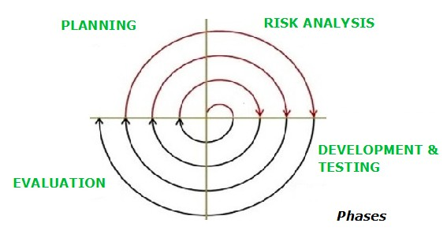

Planning :- determination of objectives, alternatives and constraints

Risk Analysis :- Analysis of alternatives and identification/resolution of risks.

Development & Testing :- Development of the “next level” product

Customer Evaluation :- Assessment of the result of engineering

1. **Explain working methodology of agile model and also write pros and cons.**

Ans. Agile SDLC model is a combination of iterative and incremental process models with focus on process adaptability and customer satisfaction by rapid delivery of working software product.

Agile methods break the product into small incremental builds. These builds are provided in iterations. Every iteration involves cross functional team working simultaneously on various areas like planning, requirements analysis, design, coding, unit testing, and acceptance testing.

At the and of the iteration a working product is displayed to the customer and important stakeholders.

Pros :-

* It’s realistic model
* Teamwork and cross training.
* Resource requirements are minimum.
* Good model for environments that change steadily.
* Easy to mange.
* Give flexibility to developer
* No planning is required

Cons :-

* Not suitable for handing complex dependencies.
* More risk
* You have to manage strict delivery management
* It’s totally depends customer feedback

1. **Draw usecase on online book shopping.**

Ans.

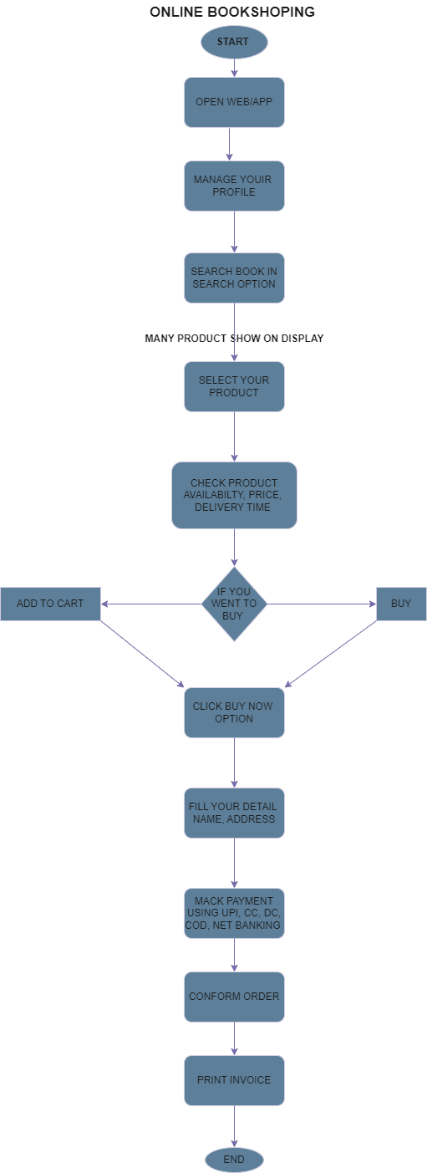

1. **Draw usecase on online bill payment system (paytm).**

Ans.

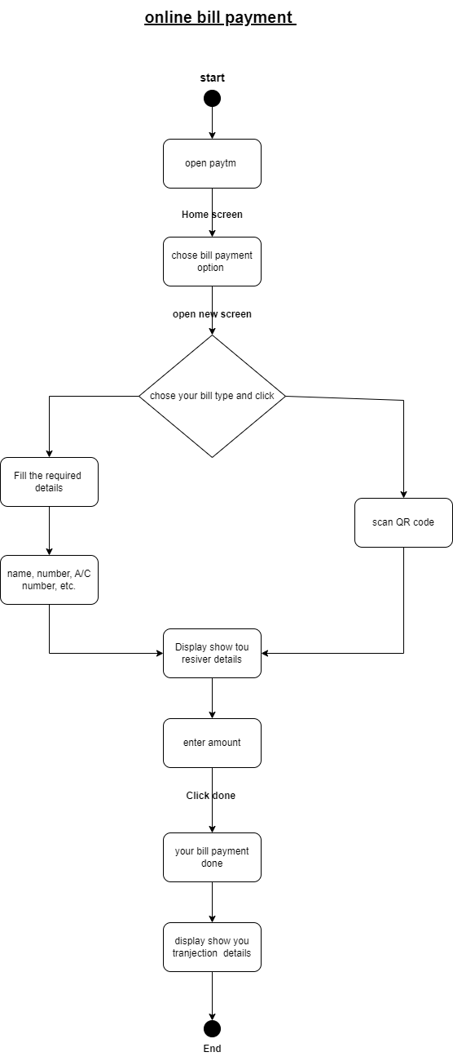

1. **Draw usecase on online shopping product using COD**

Ans.

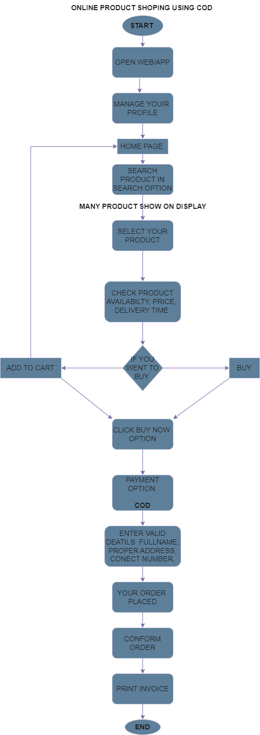

1. **Draw usecase on online shopping product using payment gateway.**

Ans.

